Support Vector Regression Machines

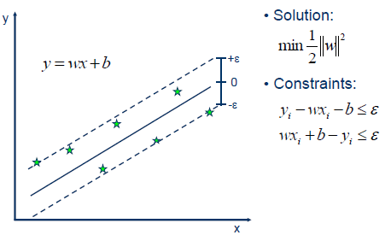

Output is a real number so it becomes very difficult to predict the information at hand which has infinite possibilities. In regression a margin of tolerance (epsilon) is set in approximation to the SVM. Aim: minimize error, individualizing the hyperplane which maximises the margin keeping in mind that part of the error is tolerated.

In ε-SV regression (Vapnik 1995), our goal is to find a function f (x) that has at most ε deviation from the actually obtained targets yi for all the training data, and at the same time is as flat as possible. In other words, we do not care about errors as long as they are less than ε, but will not accept any deviation larger than this